**Learning Report**

1. **My learning**

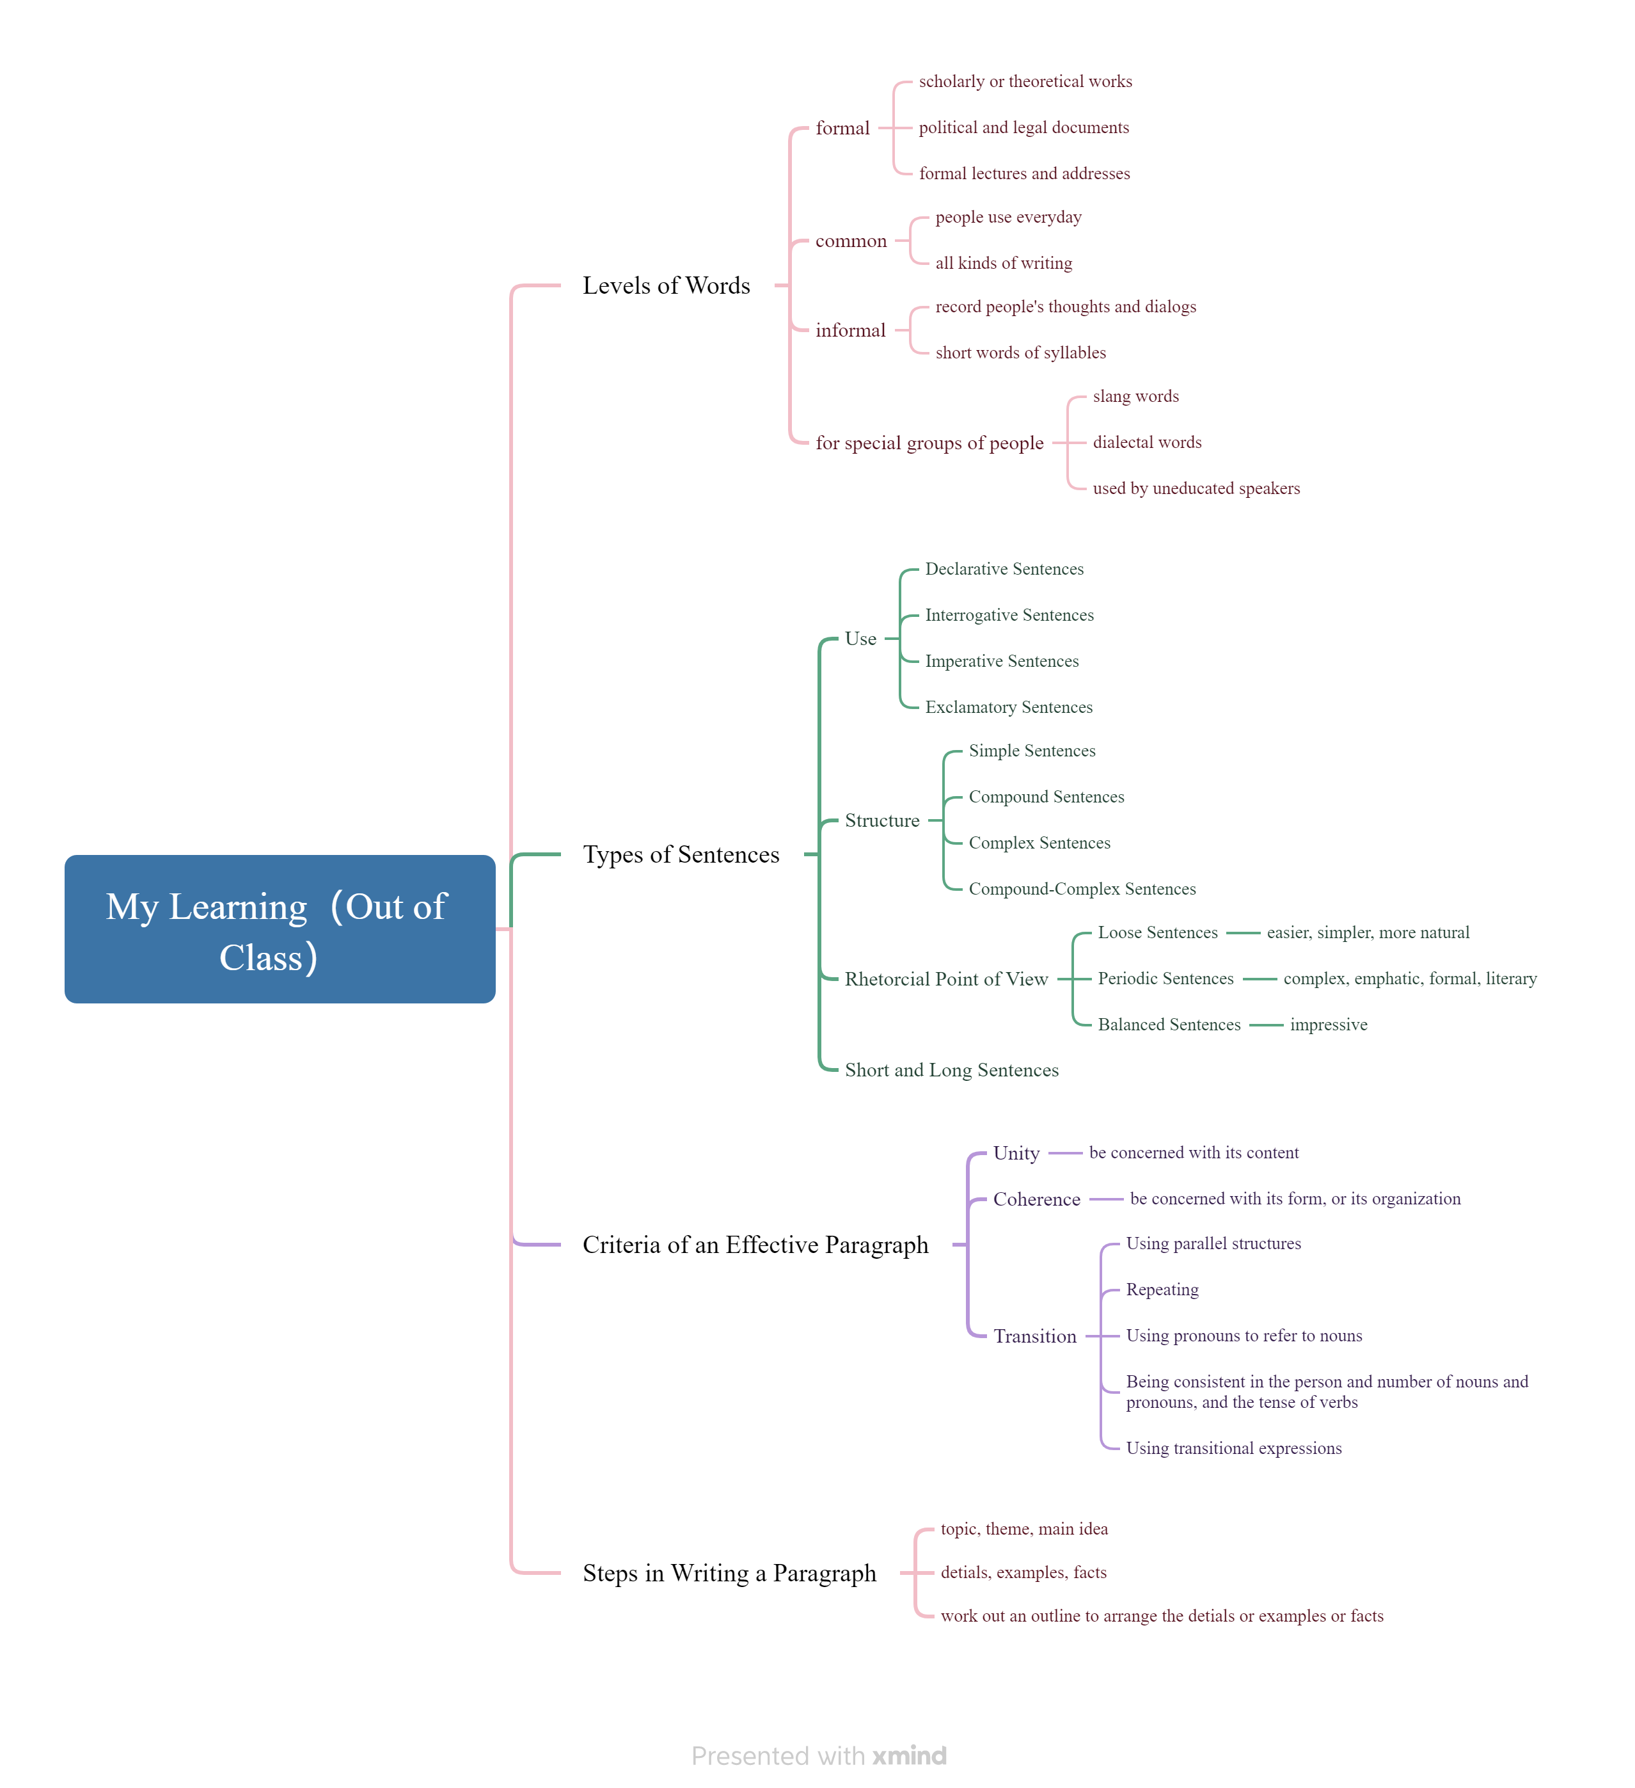

1. **Learning outcomes**

1) From extracurricular learning, I've learned that words can be categorized into three levels: formal, informal, and common. In the future, I'll be able to use words correctly according to different occasions and needs.

2) A paragraph should begin by identifying its topic. Following this, it should be expanded with details and examples to develop the body of the text. Finally, work out an outline to arrange the details or examples or facts.

3) There are many types of sentences, which can be classified based on their Use, Structure, Rhetorical Point of View, as well as their length, including both short and long sentences. Understanding these classifications can greatly assist me in comprehending the types of sentences in the future.

4) Considering Unity, Coherence, and Transition in writing a paragraph provides clear direction for future writing endeavors.